I Can…

- Roll the dice. 6

- Find the tally and Cross out that number on the tic-tac-toe board.
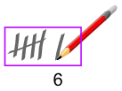

- Get three in a row to win.

